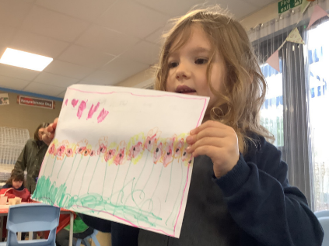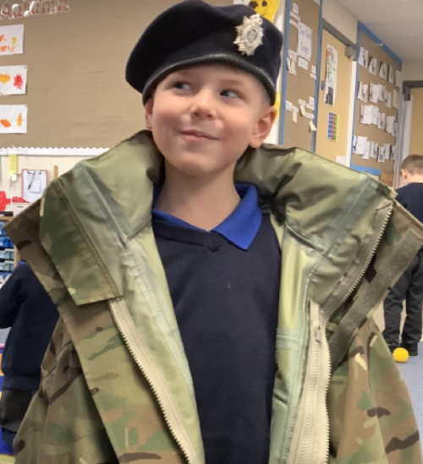

Junk Modelling:

The children have got really stuck into junk modelling this week. Please could we have some donations to help our junk modelling supply high. Anything from the recycling can be used.

It has been a busy return to school this week. The children have settled back in really well. This week it’s been all about Autumn. On Monday morning we went into the Forest School area and went on a leaf hunt to collect leaves to use in class. The children then used these leaves for threading and sorting. We have also been learning about mass and using the balance scales to test different objects and see which were heavier or lighter. Today has been all about Remembrance. Mrs Wood put her army beret on and set up and obstacle course for the children to enjoy.

Butterfly Class Newsletter

08.11.24

Little City visit:

On Wednesday morning we are having a visit from Little City, which has kindly been paid for by the Friends of Hingham School. It will be a lovely experience for the children, as they will be able to immerse themselves in different role play scenarios.

P.E Kit

Sorry for any confusion last week regarding school photos and P.E kit. This week Thursday 14th, children will need to wear their P.E kit to school.

-Colour team t-shirt

- Joggers/Shorts

- Trainers (please no laces).

