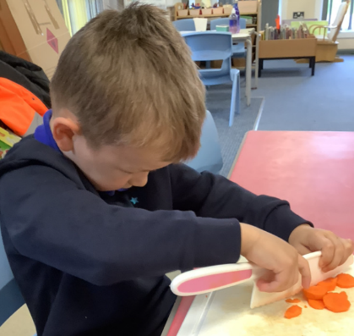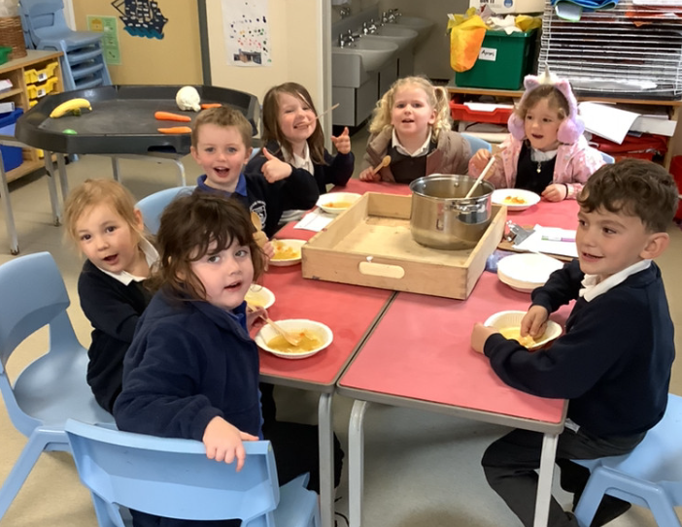

Phonics Cards: Keep using the phonics cards at home. The children are making fantastic progress and beginning to blend the sounds to help them read words.

This week our focus has been Harvest Time. The children started the week by making vegetable soup. They were amazing at chopping the carrots and parsnips. Once the soup had been cooked lots of the children tried the soup, and some even came back for second helpings! We have also been doing lots of sorting and matching this week. We spent some time sorting fruits and vegetables and talking about how they are different. The children have also been matching numbers to different amounts. They did this really well and their counting was amazing!

Butterfly Class Newsletter

18.10.23

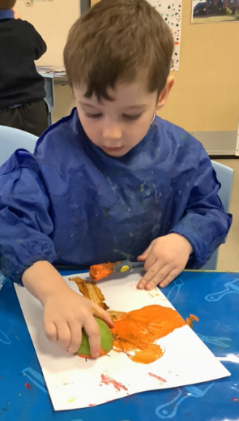

Half Days:

It has been an incredibly long half term and the children have settled in so well and learnt a lot in such a short space of time. This can be extremely tiring for children, if you feel they are tired please let us know and we can accommodate, especially in the final week of a very long and busy half term.

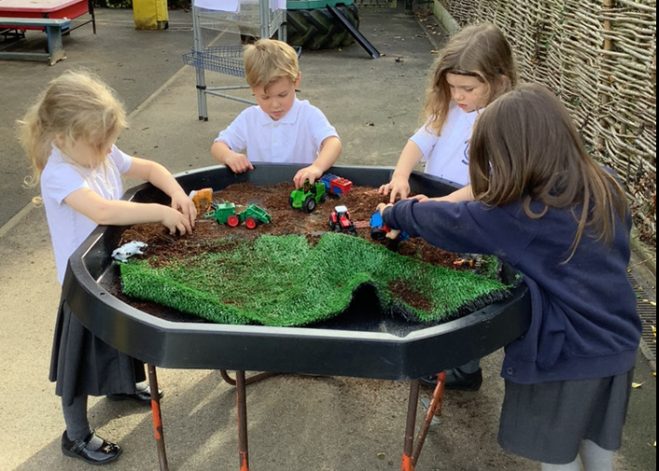

Autumn Treasures:

The children have taken a real interest in the change of the season. They have been talking about conkers and fallen leaves. Please feel free to make a collection of Autumn objects and bring into school for us to use in class.