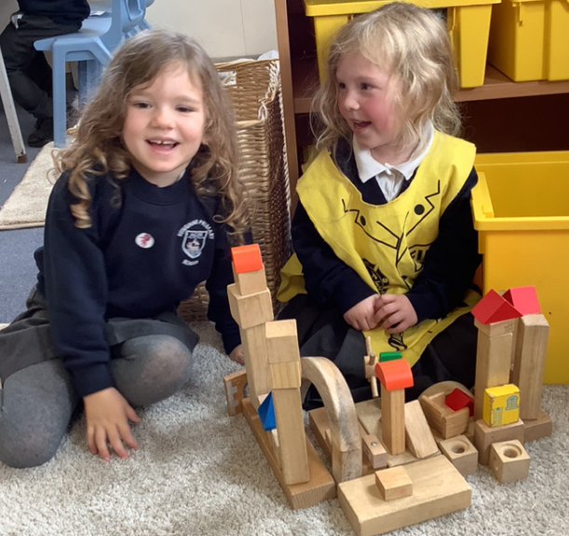

EDP First Class Supplement:

The children will be pictured in the EDP on Wednesday, as part of their First Class supplement. Set a reminder to buy a copy of the EDP on Wednesday 16th October.

It’s been another busy week in Butterfly Class! This week we have been thinking about the fire service. On Wednesday we had a visit from a fire fighter, who talked to us about being a fire fighter and how to stay safe. The children have also been very excited by the ‘All About Me’ box. They been listening to each other and asking questions about their special objects. It is definitely helping us to get to know each other. They are all patiently waiting their turn, so keep an eye out for your child coming home with the box.

Butterfly Class Newsletter

11.10.23

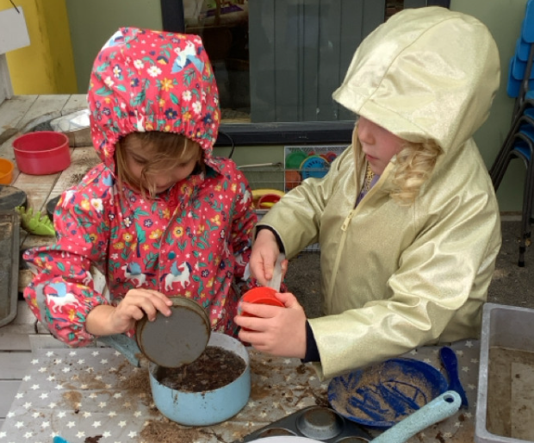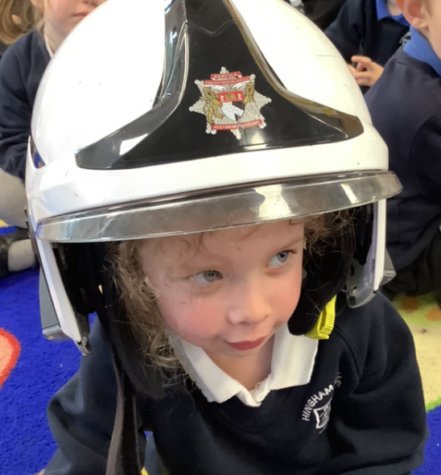

Autumn Treasures:

The children have taken a real interest in the change of the season. They have been talking about conkers and fallen leaves. Please feel free to make a collection of Autumn objects and bring into school for us to use in class.

Phonics Cards: Keep using the phonics cards at home. The children are making fantastic progress and beginning to blend the sounds to help them read words.

