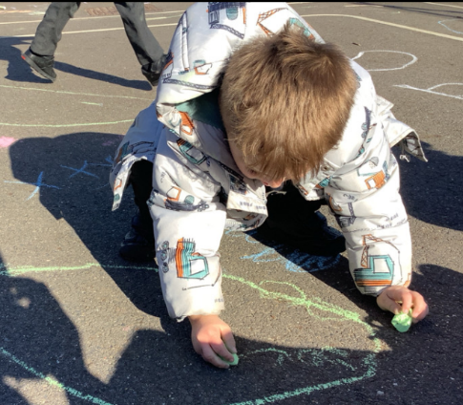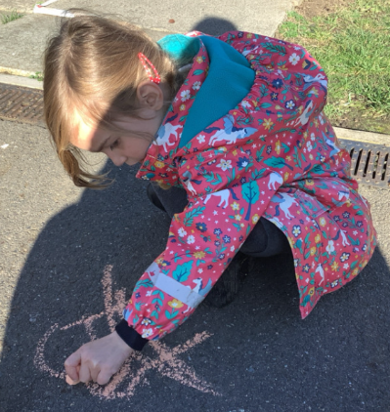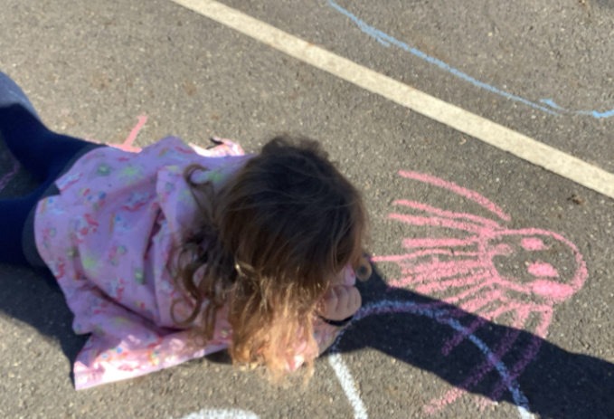

Café afternoon:

The first week back after half term we will be baking with the children and setting up a café, where we will be giving them the experience of being in a restaurant. We will be having flapjacks and milkshakes. Please let us know if you have any concerns.

This week has been all about festivals and fireworks. We started the week learning about the festival of Diwali. The children made their own Rangoli patterns using chalk and made diva lamps to celebrate the festival of light. We also talked about fireworks and how to stay safe. The children then made their own rockets. They have had such a busy half term and have worked really hard. Have a restful half term, the children definitely deserve it!

Phonics Cards: Keep using the phonics cards at home. The children are making fantastic progress and beginning to blend the sounds to help them read words.

Butterfly Class Newsletter

24.10.23

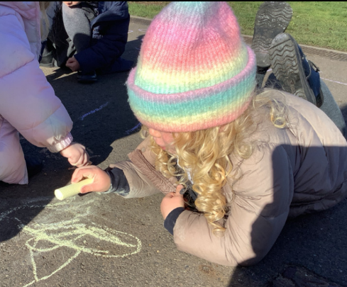

P.E Kit

After half term the children will need to come to school in their P.E kit on a Thursday. Uniform required:

-Colour team t-shirt

- Joggers/Shorts

- Trainers (please no laces).