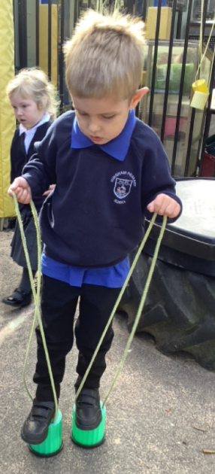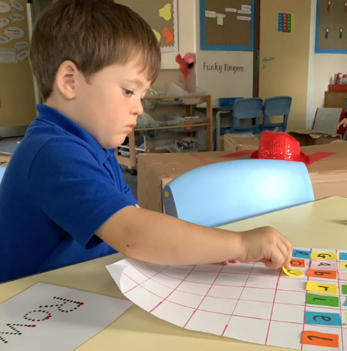

Name recognition:

This year we have lots of children who share the same initial within their first name. This is proving tricky for the children when it comes to finding their names on various items in the class including shooting stars, water bottles and pegs. It would be really helpful if children learnt to recognise their own name. We are doing lots of activities to promote this at school but more practise at home would also help as well.

We are really getting into the swing of all the school routines this week. Mrs Wood has even been able to move the cones on the field to allow the children to use the trim trail during lunchtime. This week we have been working on recognising and writing our names. The children worked on finding the letters in their name and putting the letters in the correct order. The children then counted how many letters they have in their name and compared this to a friend, to decide whether they had more or less. The children have really been growing in confidence this week and learning more about each other. It’s been another wonderful week!

Butterfly Class Newsletter

20.09.23

Our Houses

Thank you to those who have already sent in pictures. We will be continuing to look at where we live and thinking about how all our houses are different. Please could you send a picture of your child’s house to [butterfly@hinghamprimary.org.uk](mailto:butterfly@hinghamprimary.org.uk)

