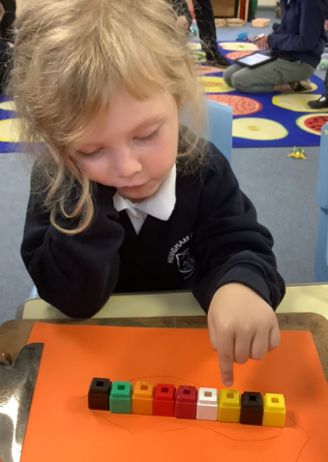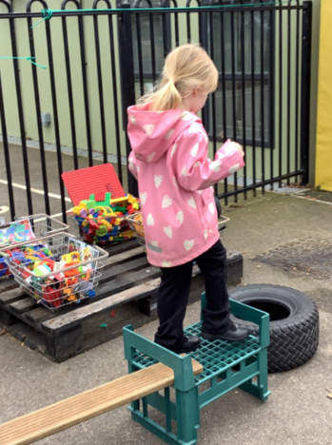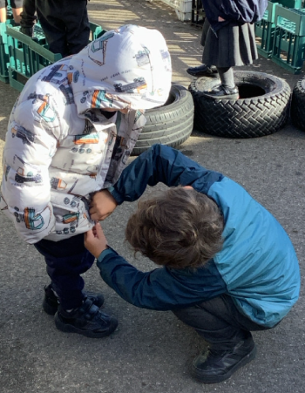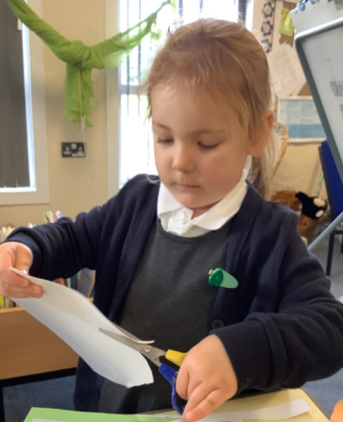

It has been wonderful to have the children in for their first full week. The children have been really getting stuck with the routines in Butterfly Class this week. It is wonderful as we are beginning to see some of their little personalities come out. They have really enjoyed getting to know each other and have been playing cooperatively together. They have loved getting stuck in, in the outdoor area. They have been working together to use the loose parts to build an obstacle course and practising their balance while walking across the planks. They have also enjoyed testing their balance further by using the slits.

Our Houses

Next week we will be looking at where we live and thinking about how all our houses are different. Please could you send a picture of your child’s house to [butterfly@hinghamprimary.org.uk](mailto:butterfly@hinghamprimary.org.uk)

Independence:

As the weather now seems to have taken a rather cold turn, we are trying to help the children to be independent in putting on their coats and zipping them up. Please encourage this as much as possible at home as well.

Butterfly Class Newsletter

13.09.23

It has been a very busy and full-on week for the children. We are hoping you all have a relaxing an enjoyable weekend, ready to go for next week. As always, please talk to us if you feel your child is tired and would benefit from an afternoon at home. Sometimes this can make a huge difference the next day.