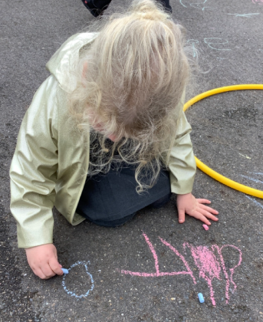

People Who Help Us:

Next week we will start to look at the community and people who help us. We have got visitors coming into class to talk to the children about various jobs including: a scientist, a dental nurse and a firefighter. We are very excited to learn about what these jobs involve and to learn more about our wider community.

This week the children have been beginning to establish their phonics knowledge. We have learnt lots of new sounds and we are beginning to work together to blend these sounds to help us read words. We have been working hard to ensure the way we say these sounds is pure, if you are unsure how to pronounce any sounds there are useful links on the Little Wandle website to help you support your child with their reading. As the children become confident with blending sounds to read words, they will be sent home with a reading book (more information will follow on this). [For parents | Letters and Sounds (littlewandlelettersandsounds.org.uk)](https://www.littlewandlelettersandsounds.org.uk/resources/for-parents/)

Butterfly Class Newsletter

27.09.23

