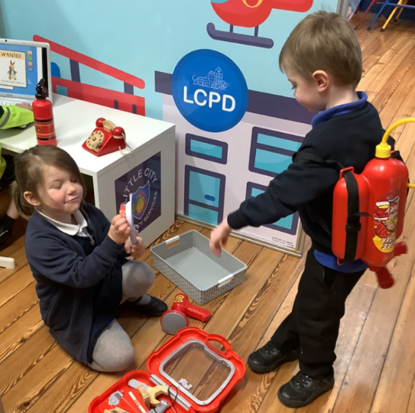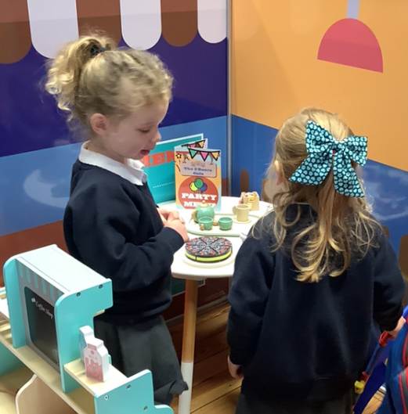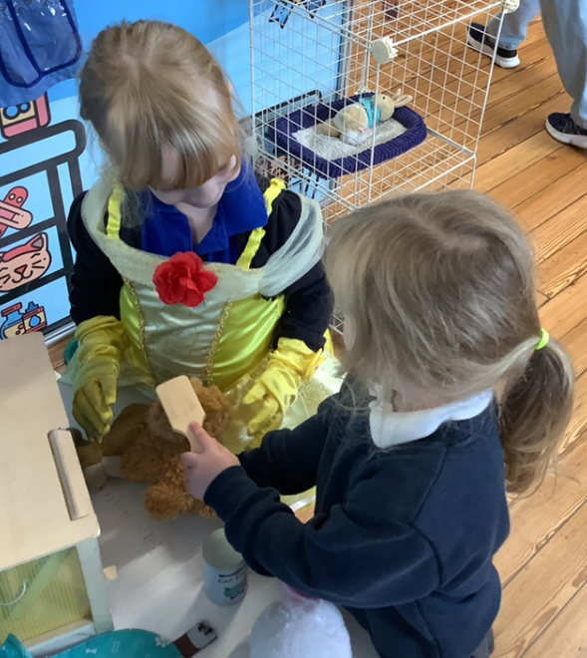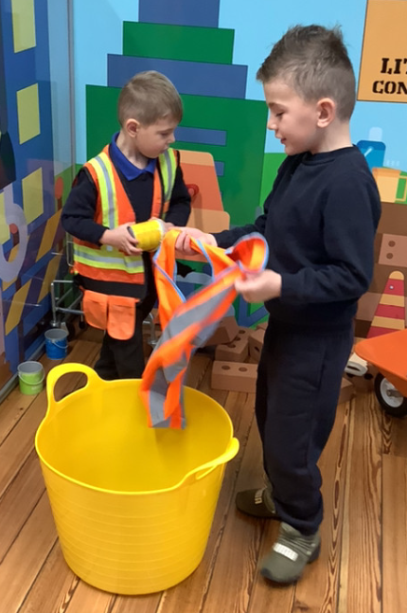

High Frequency words:

This week the children have come home with the tricky words we have learnt so far this year. Please use these alongside the sound cards at home. Use a few at a time as to not overwhelm the children.

Junk Modelling:

The children have got really stuck into junk modelling this week. Please could we have some donations to help our junk modelling supply high. Anything from the recycling can be used.

We have had another exciting week in Butterfly Class this week. The highlight of the week was the Little City visit. The children really enjoyed playing in all the different areas and immersing themselves in different role play activities. We had some fantastic waiters and waitresses in the café, some excellent workmen and really dedicated members of the emergency services. We have also been learning about patterns this week. The children have been amazing at creating their own patterns using objects in the classroom, they have also been able to spot mistakes in some of my patterns.

Butterfly Class Newsletter

15.11.24