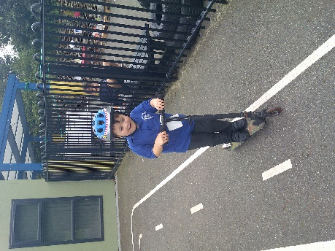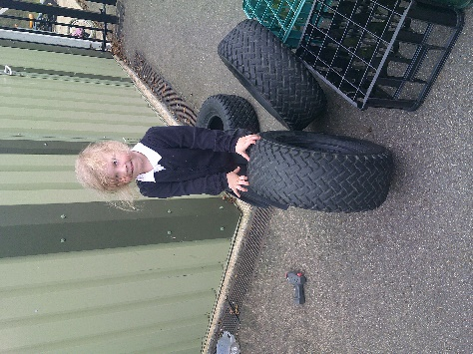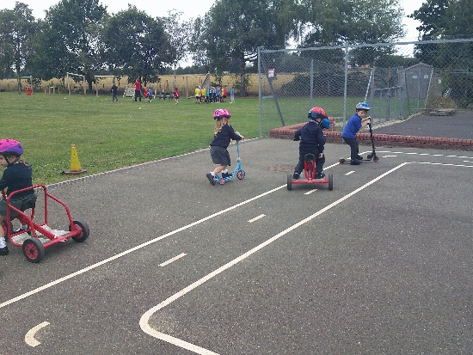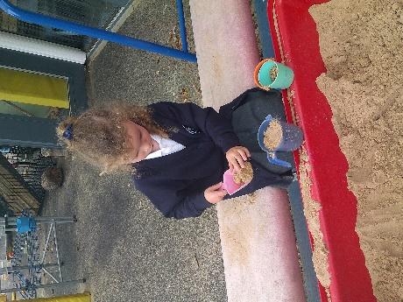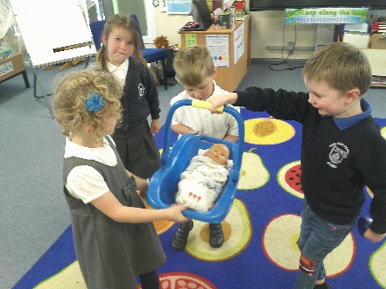

Independence:

We are encouraging the children to try and be as independent as possible when it comes to eating and toileting. Please encourage this at home as much as possible.

The children have settled in really well this week. We have never had so many children with us full time from September and they have risen to the challenge and are growing in confidence every day. We have been focusing on getting to know each other. The grown ups in Butterfly Class have been sharing what makes them special by using the ‘All About Me’ box. The adults in school are going to continue introducing themselves to the children and then we will begin to send the box home with one of the children each night for them to fill and share what makes them special with their friends.

Butterfly Class Newsletter

06.09.23

We have loved having the children in full time. As well as the children are settling in, we are aware how big a change coming to school can be. Not only are they learning the names of their new friends and the adults around school, they are learning new routines and their way around a new environment. The children are bound to find this overwhelming and tiring at times. If you feel your child would benefit from going home at lunch on certain days, please don’t be afraid to allow this. A good rest will sometimes help with the transition process.

