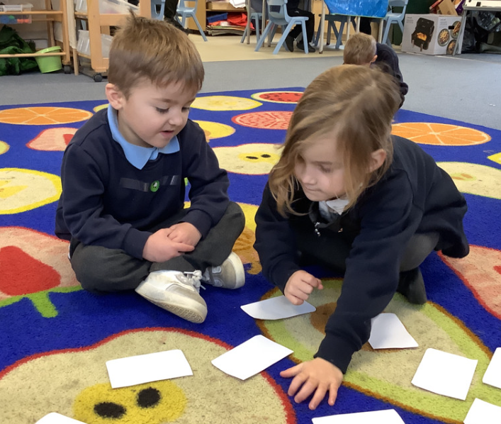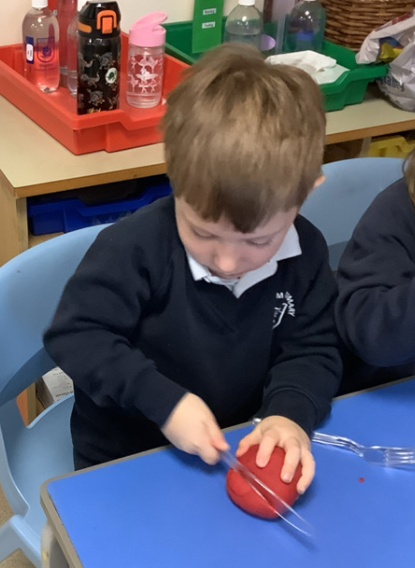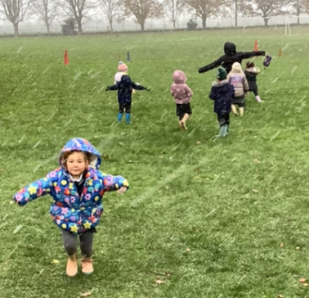

Nativity Costumes:

We will be angels in the Nativity. Costumes will be provided for the children. They will just need to have warm clothes underneath.

Junk Modelling:

The children have got really stuck into junk modelling this week. Please could we have some donations to help our junk modelling supply high. Anything from the recycling can be used.

It’s been a cold week in Butterfly Class this week. The children loved our impromptu run around in the snow and hot chocolate on Wednesday afternoon! The children have been getting really stuck into learning the songs for the Nativity. We have been playing them in the classroom while we have been working and the children are really enjoying singing and dancing along. With the change in the weather, we are trying to encourage the children to be as independent as possible when zipping up their coats. Please could you support them doing this at home as well.

Butterfly Class Newsletter

22.11.24

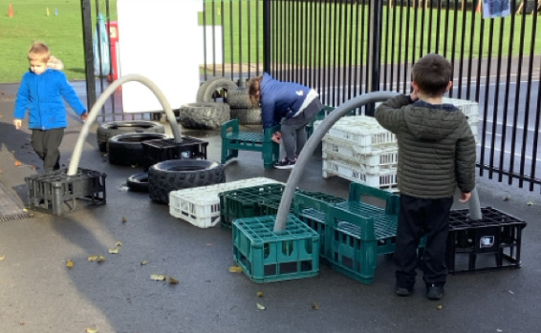

Parent walkers:

We will be walking to the church for two rehearsals for the Nativity. On Tuesday 10th and Wednesday 11th from 9:30. Please let us know if you are available to help us walk to and from the church.