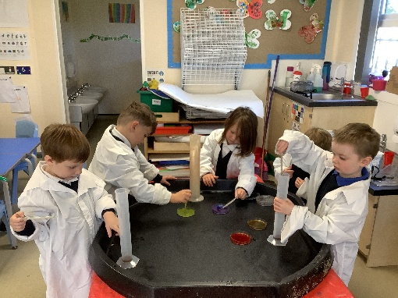

All About Me:

Starting from next week the children will be bringing home the ‘All About Me’ box. The adults around school have filled the box and shared their favourite things with Butterfly Class and now it is the turn of the children. They can fill the box with up to 5 things. These could include: a baby photograph, a picture of their family or just their favourite things for them to share with their friends. The box will come with a different child every few days, so keep your eyes peeled for this.

What a busy week we have had this week! Our week started strangely as we came in Monday to find our Vets had been ruined and all the animals had disappeared. The police came to visit us and talk about their job and help us with our investigation. We were also lucky enough to have a visit from a dental nurse this week. We were allowed to have a go at brushing the big set of teeth and she spoke to us about the importance of making sure we look after our teeth and how to do this. We also had a visit from a scientist from the Norfolk and Norwich hospital who spoke to us about their job in the laboratory and the children loved then having a go with some pipettes themselves.

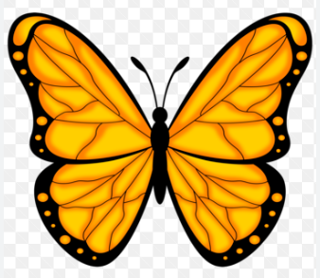Butterfly Class Newsletter

04.10.23

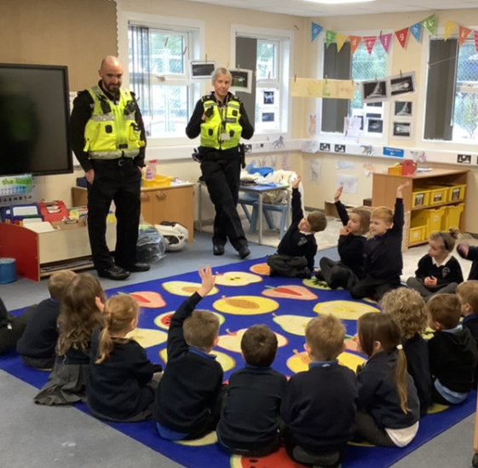

Autumn Treasures:

The children have taken a real interest in the change of the season this week. They have been talking about conkers and fallen leaves. Please feel free to make a collection of Autumn objects and bring into school for us to use in class.

Phonics Cards:

You may have seen the children have come home with some phonics cards this week. These are the sounds we have learnt so far and how to form the letters correctly. Please cut these out and use them at home to support your child’s learning.