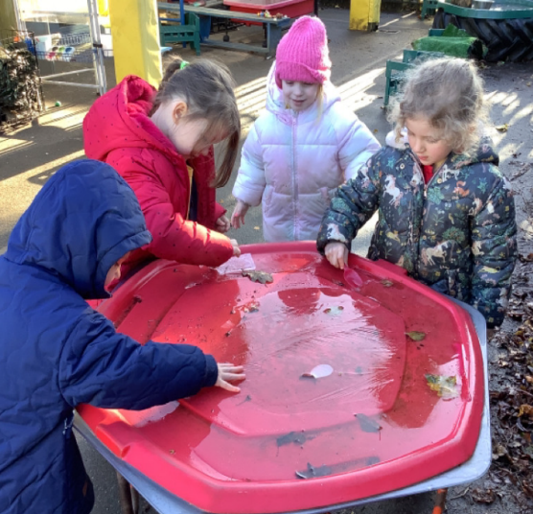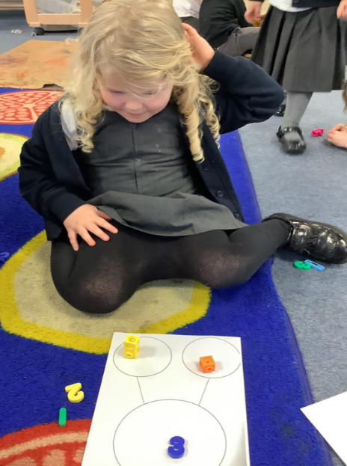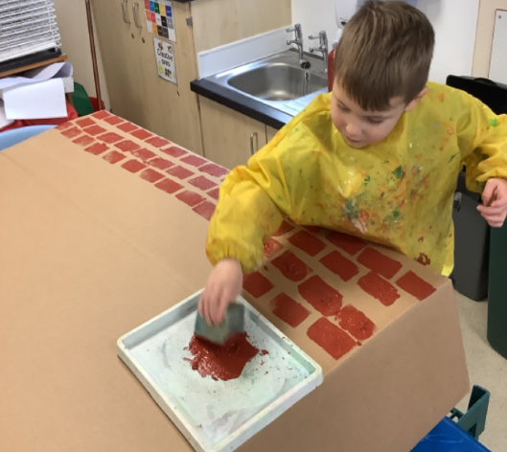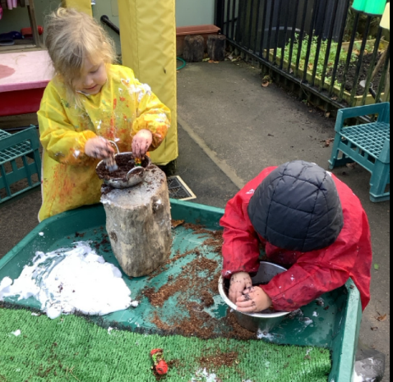

Phonics workshop:

Thanks to all those that attended the phonics workshop. For those who were unable to come, the children will be sent home with the handouts next week.

Snacks:

A polite reminder about the snacks children are bringing in from home. We ask for the children to bring in either fruit or vegetable in a reusable pot. As we are a nut free school, we ask for nothing that comes in a wrapper as we are unable to monitor this.

Another busy week in Butterfly Class. The children have really enjoyed retelling We’re Going on A Bear Hunt story. They even set up their own Bear Hunt obstacle course and enjoyed talking about whether they were going through the long, wavy grass or the thick oozy mud. They made a cave to try and entice a bear to come and hibernate in. This led to us thinking about other animals that might be getting ready to hibernate at this time of year. Towards the end of the week the children were investigating with some of the frozen items in the outdoor area.

Butterfly Class Newsletter

29.11.24

Parent walkers:

We will be walking to the church for two rehearsals for the Nativity. On Tuesday 10th and Wednesday 11th from 9:30. Please let us know if you are available to help us walk to and from the church.