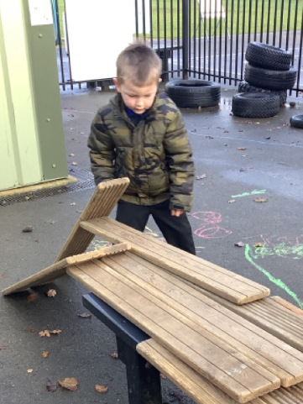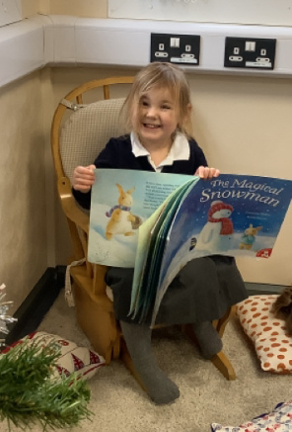

Nativity:

Next week we will be walking to the church Tuesday and Wednesday morning. Please make sure children come to school with warm clothing. On Wednesday evening children can arrive at the church from 5pm, ready for us to dress them. A member of staff will collect them from the door as parents are asked to wait outside until nearer 5:30pm.

The festive season has truly begun this week in Butterfly Class. Our home corner has turned into a festive living room. The children have been helping us with this by making the fireplace, making stockings to hang and decorating the tree. The children have been taking it in turns to chose a festive story each day and these have then been added into the living room. The children have then loved snuggling into the cosy armchair and reading these. We have been looking at shapes this week, with a focus on circles and triangles. The children enjoyed making their own pizzas using different shaped toppings.

Butterfly Class Newsletter

06.12.24

Junk Modelling:

Thank you all so much for your junk modelling donations. We now have lots of stuff for the children to make with. We have enough to last until Christmas. We will send another message in the New Year when we are running low again.

